25.8: a)
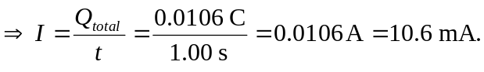
b) Current flows, by convention, in the direction of positive charge. Thus, current flows with 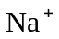 toward the negative electrode.

